Parameter Store
Create parameter Parameter details Name lab-db-endpoint, lab-db-name, lab-db-port
Tier Standard
Type String
Data type text
Click Create parameter
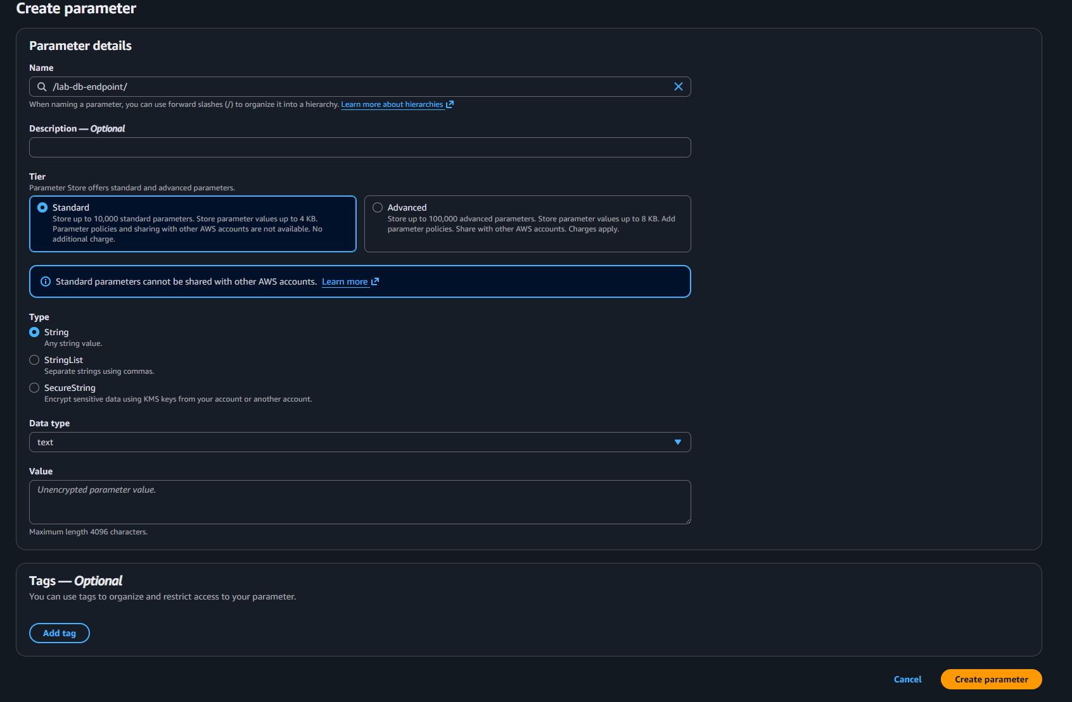

Create new policies to put on ec2
The First Policy: EC2-CloudWatchAgent-Custom
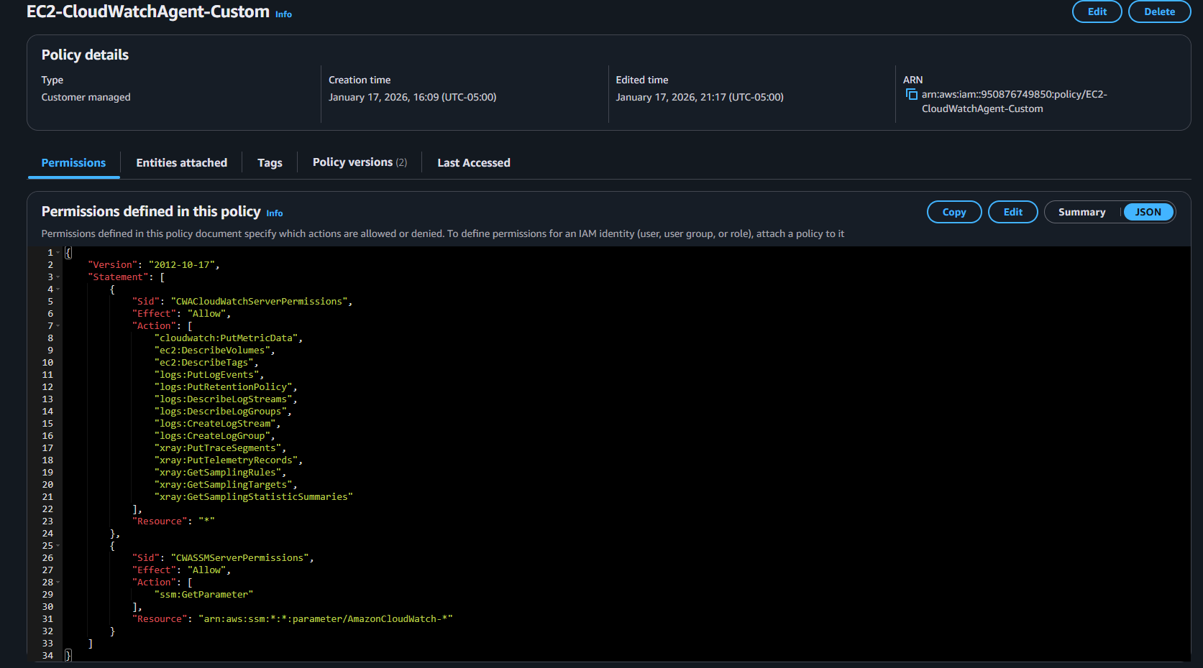
{
"Version": "2012-10-17",
"Statement": [
{
"Sid": "CWACloudWatchServerPermissions",
"Effect": "Allow",
"Action": [
"cloudwatch:PutMetricData",
"ec2:DescribeVolumes",
"ec2:DescribeTags",
"logs:PutLogEvents",
"logs:PutRetentionPolicy",
"logs:DescribeLogStreams",
"logs:DescribeLogGroups",
"logs:CreateLogStream",
"logs:CreateLogGroup",
"xray:PutTraceSegments",
"xray:PutTelemetryRecords",
"xray:GetSamplingRules",
"xray:GetSamplingTargets",
"xray:GetSamplingStatisticSummaries"
],
"Resource": "*"
},
{
"Sid": "CWASSMServerPermissions",
"Effect": "Allow",
"Action": [
"ssm:GetParameter"
],
"Resource": "arn:aws:ssm:*:*:parameter/AmazonCloudWatch-*"
}
]
}

Second Policy: AmazonSSMManagedInstanceCore
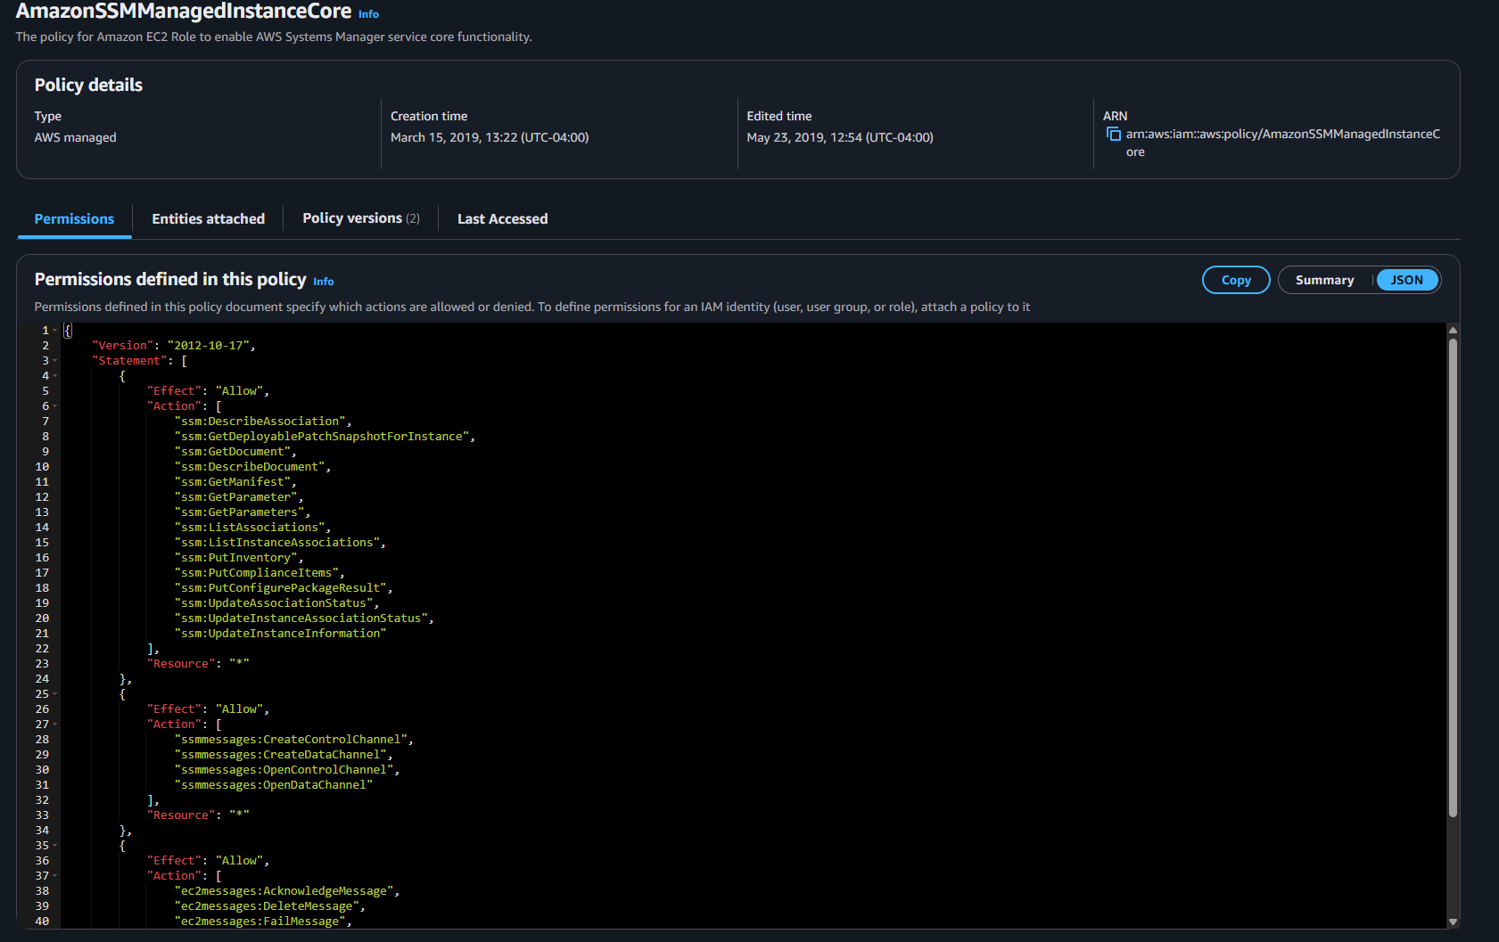
{
"Version": "2012-10-17",
"Statement": [
{
"Effect": "Allow",
"Action": [
"ssm:DescribeAssociation",
"ssm:GetDeployablePatchSnapshotForInstance",
"ssm:GetDocument",
"ssm:DescribeDocument",
"ssm:GetManifest",
"ssm:GetParameter",
"ssm:GetParameters",
"ssm:ListAssociations",
"ssm:ListInstanceAssociations",
"ssm:PutInventory",
"ssm:PutComplianceItems",
"ssm:PutConfigurePackageResult",
"ssm:UpdateAssociationStatus",
"ssm:UpdateInstanceAssociationStatus",
"ssm:UpdateInstanceInformation"
],
"Resource": "*"
},
{
"Effect": "Allow",
"Action": [
"ssmmessages:CreateControlChannel",
"ssmmessages:CreateDataChannel",
"ssmmessages:OpenControlChannel",
"ssmmessages:OpenDataChannel"
],
"Resource": "*"
},
{
"Effect": "Allow",
"Action": [
"ec2messages:AcknowledgeMessage",
"ec2messages:DeleteMessage",
"ec2messages:FailMessage",
"ec2messages:GetEndpoint",
"ec2messages:GetMessages",
"ec2messages:SendReply"
],
"Resource": "*"
}
]
}
Add them to the role you created for the EC2

System Manager
Run Command Run command
Run a command
Command document: AWS-ConfirgeAWSPackage
Document version: Default
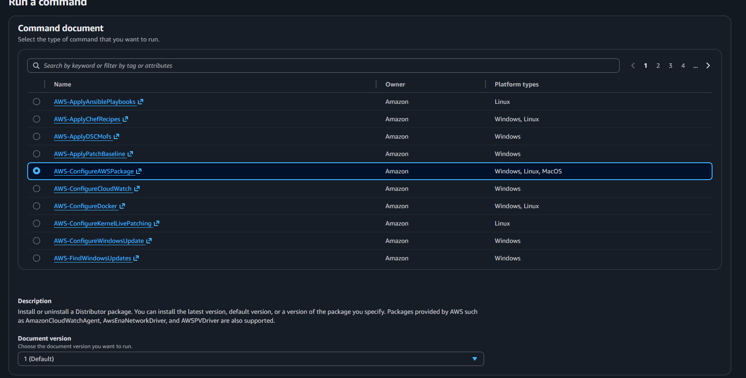
Command parameters
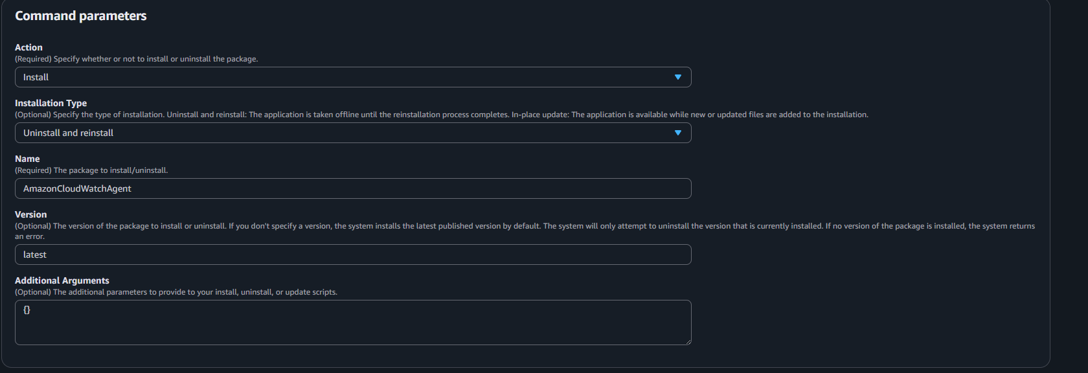
Target selection
Choose instances manually
Choose the instance that you are using
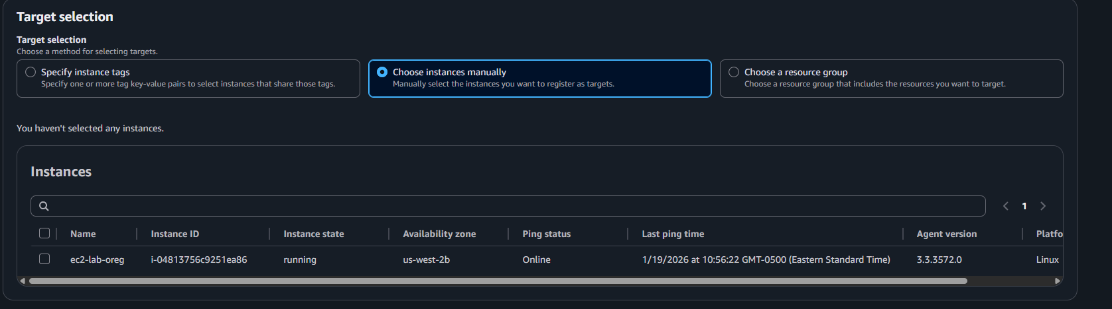
Output options
Enable CloudWatch logs
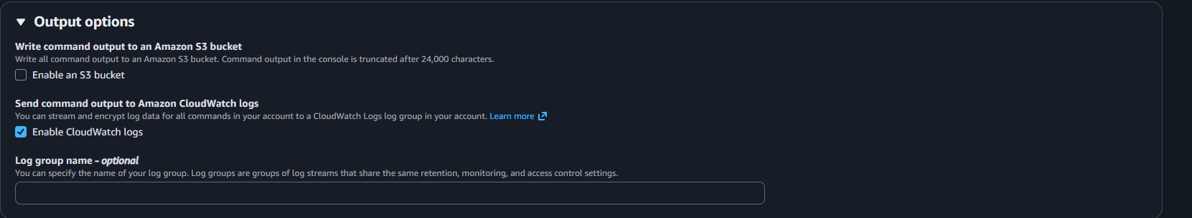
Leave the rest default Click on Run
Now go through the process again this time using: AWS-RunShellScript
Depending on your set up you may have to do AWS-RunShellScript 2 or 3 times
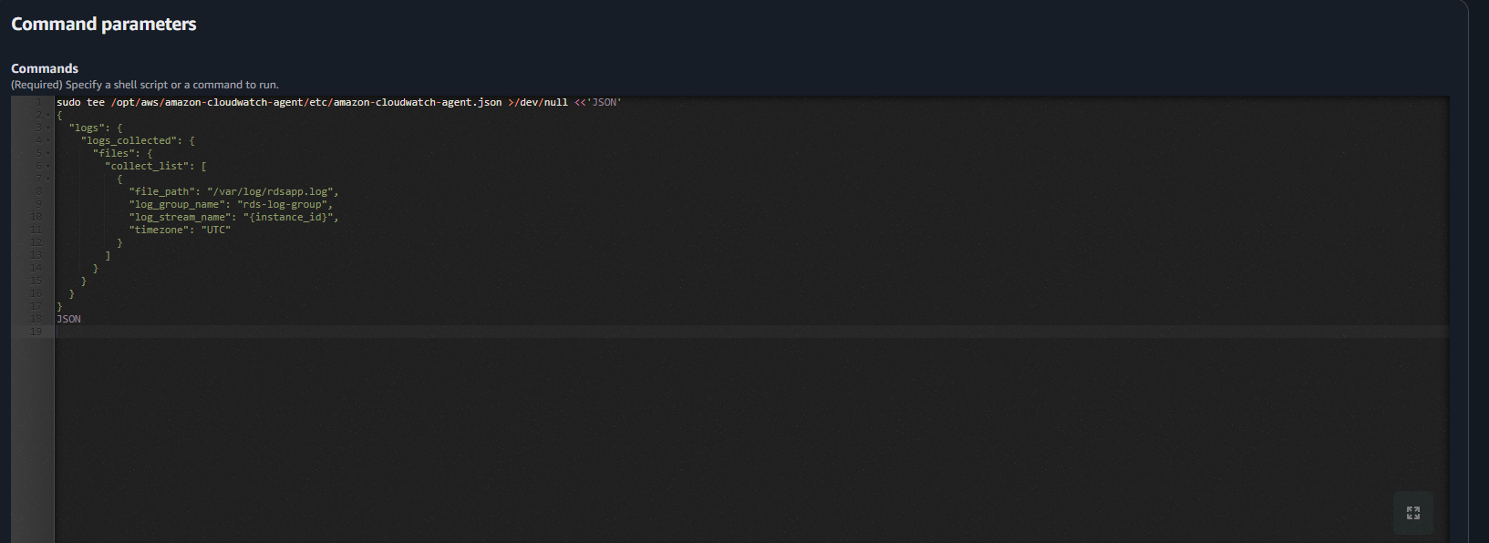
For the first use this and change the script to match what you name your log group name
Target selection is the same as above, the different is Output options don’t click any
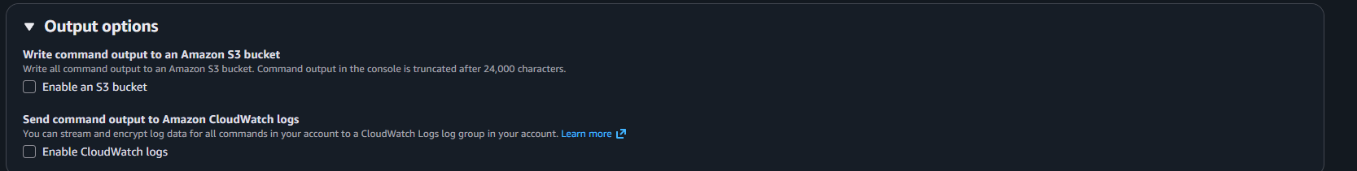
Click run
Now run this same run command again but this time us this script
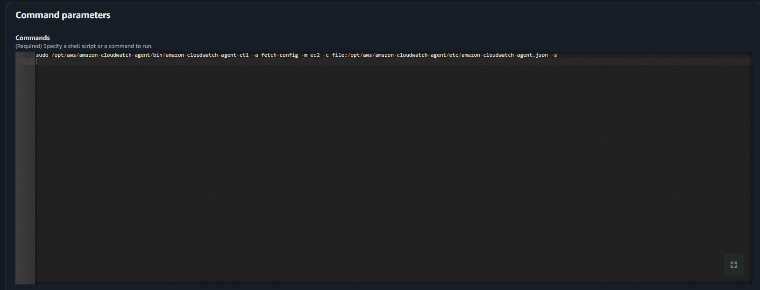
Same command parameters and Output options
Click run
My agent didn’t support journald so I had to run this as well
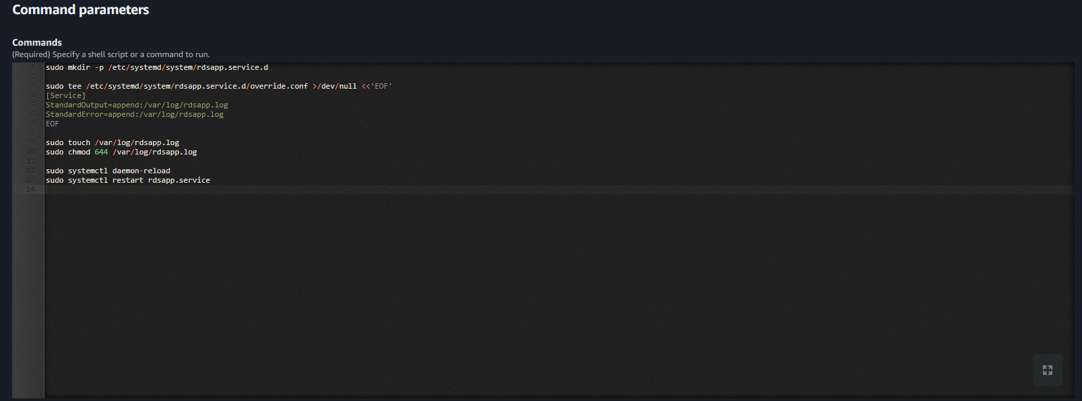
Some of this stuff may be for my setup specially and you may not have to do any of it or some of it. I believe this could be a case-by-case thing. But hopefully this gets you on the right path.

Log Group
Log management create log group
Create log group Log group details
Log group name: rds-log-group
Retention setting: you choose
Click Create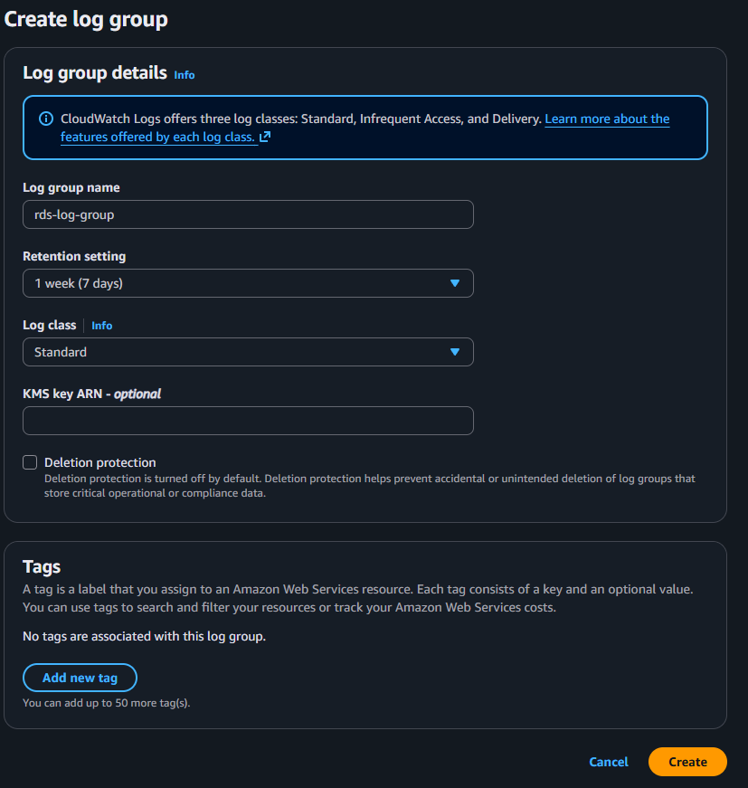

click in box, go to actions create metric filters
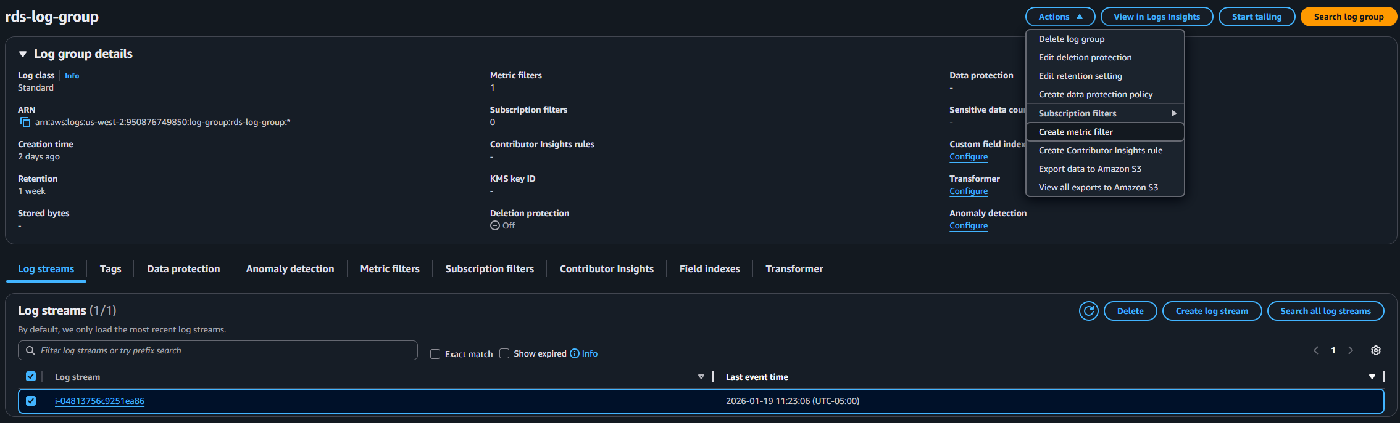

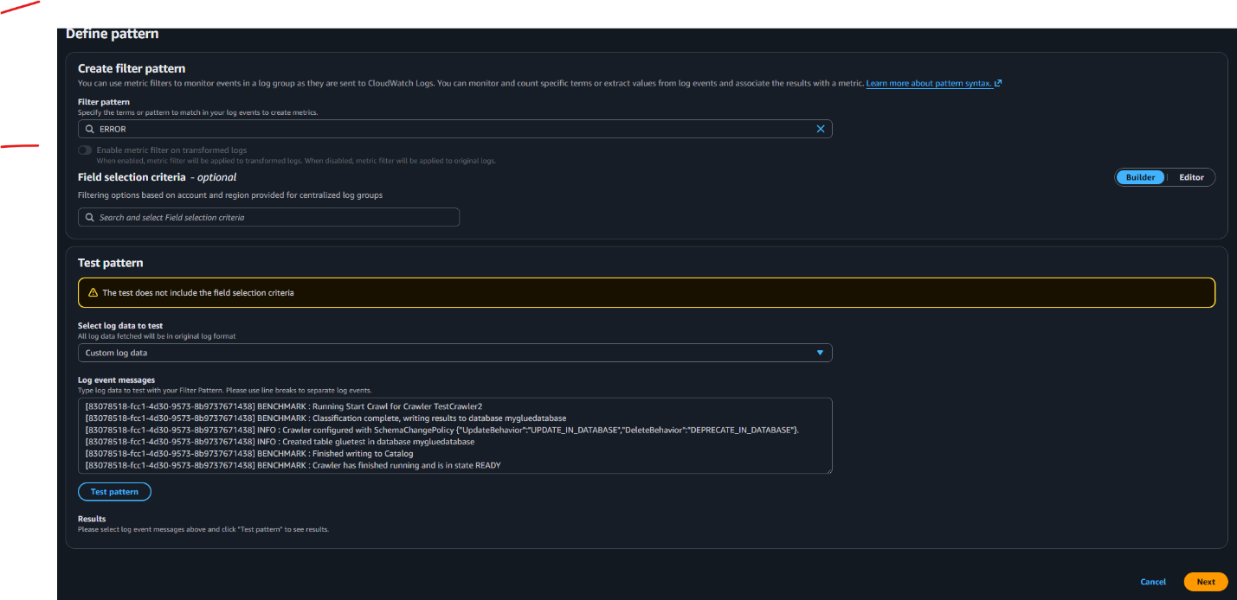
Filter pattern ERROR Next

Filter name: rds-connection-error
Metric details
Metric namespace: Lab/RDSapp
Metric name: DBConnectionErrors
Metric value: 1
Next
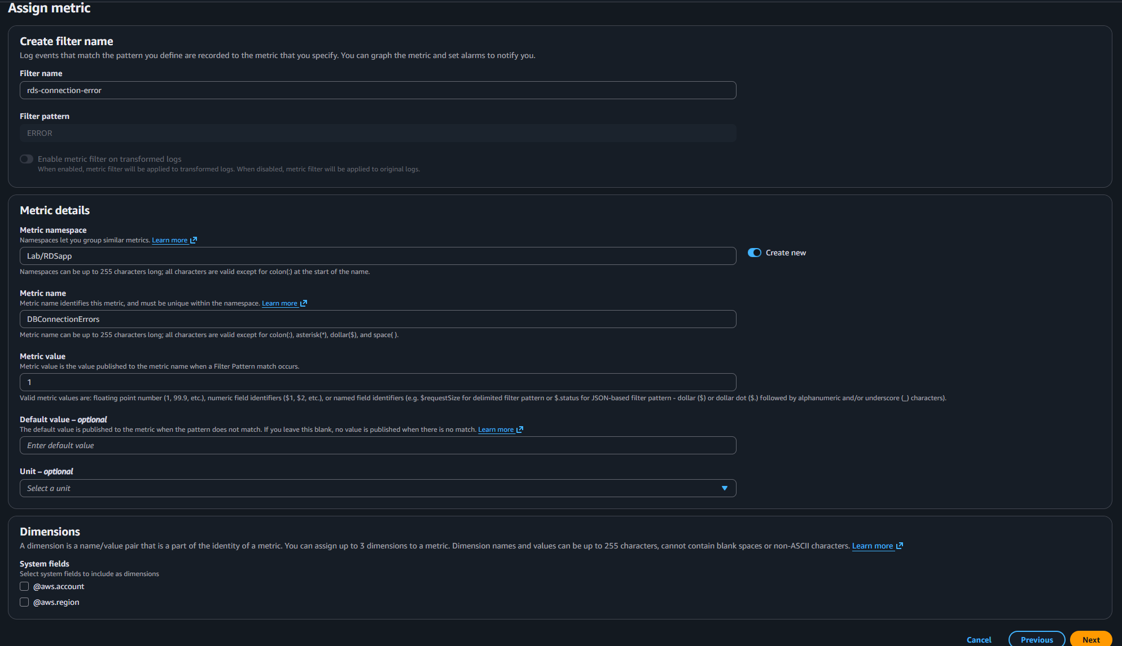
Review and creates Create metric filter
Click on the metric filter you just created and create alarm
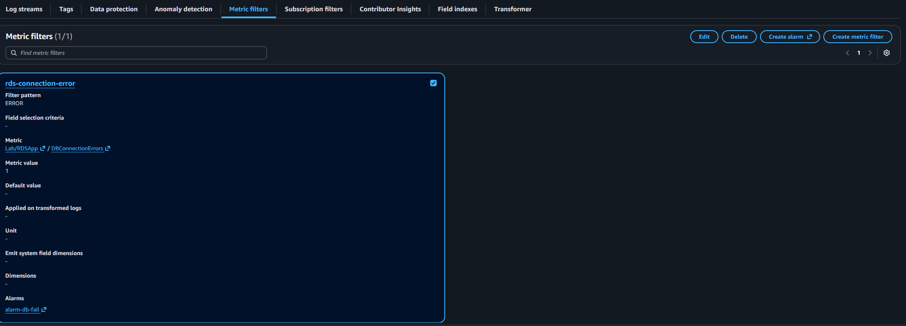
Specify metric and conditions
Metric
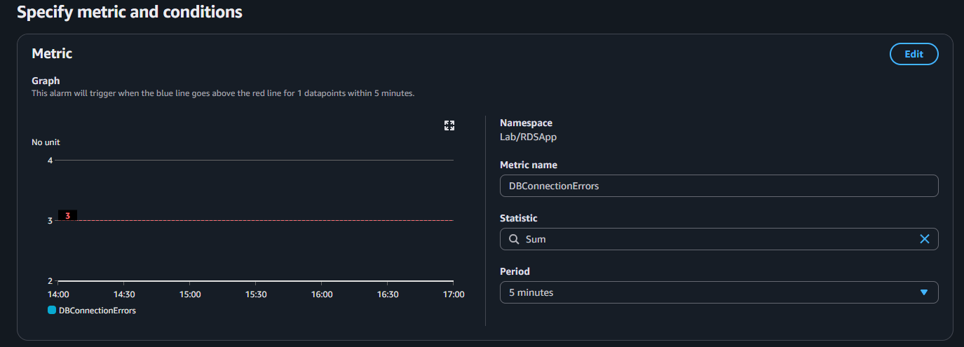

Conditions
Threshold type: Static
Whenever DBConnectionErrors is: Greater/Equal >= threshold
Than…: 3
Additional configuration
Datapoints to alarm: 1 out of 1
Missing data treatment: Treat missing data as missing
Click next
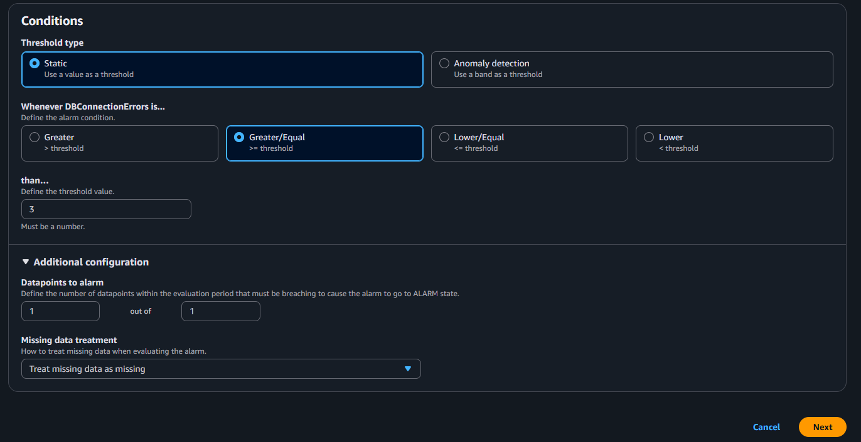

Configure actions
Notification
Alarm state trigger: In alarm
Send a notification to the following SNS topic: Select an existing SNS topic
Send a notification to: the topic you create in SNS
Email(endpoints): the subscription you created
Click Next
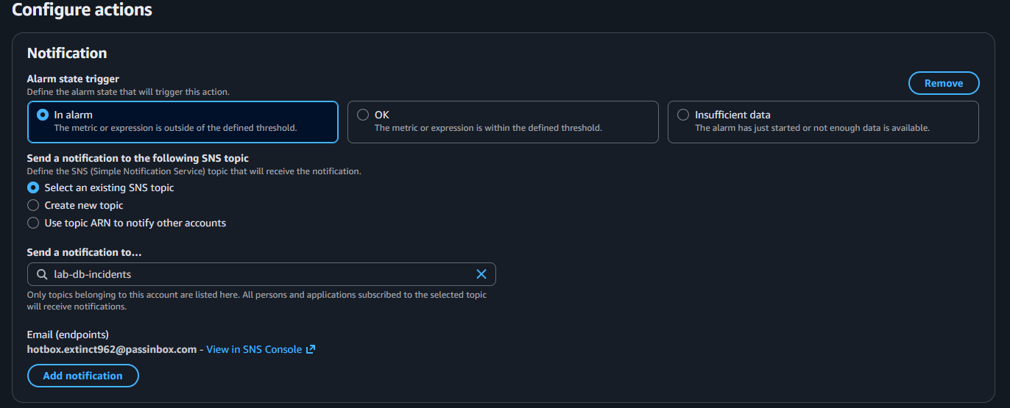
Add alarm details
Alarm name: alarm-db-fail
Click next
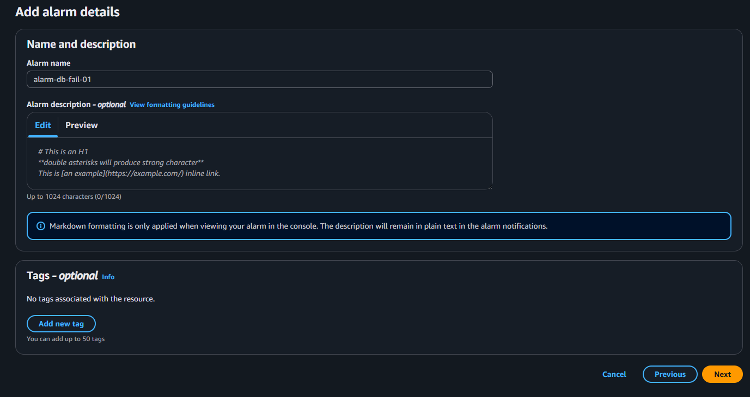
Preview and create
Click Create Alarm

SNS
Topics Create topic
Details: Standard
Name: lab-db-incidents
Everything else default
Click create topic
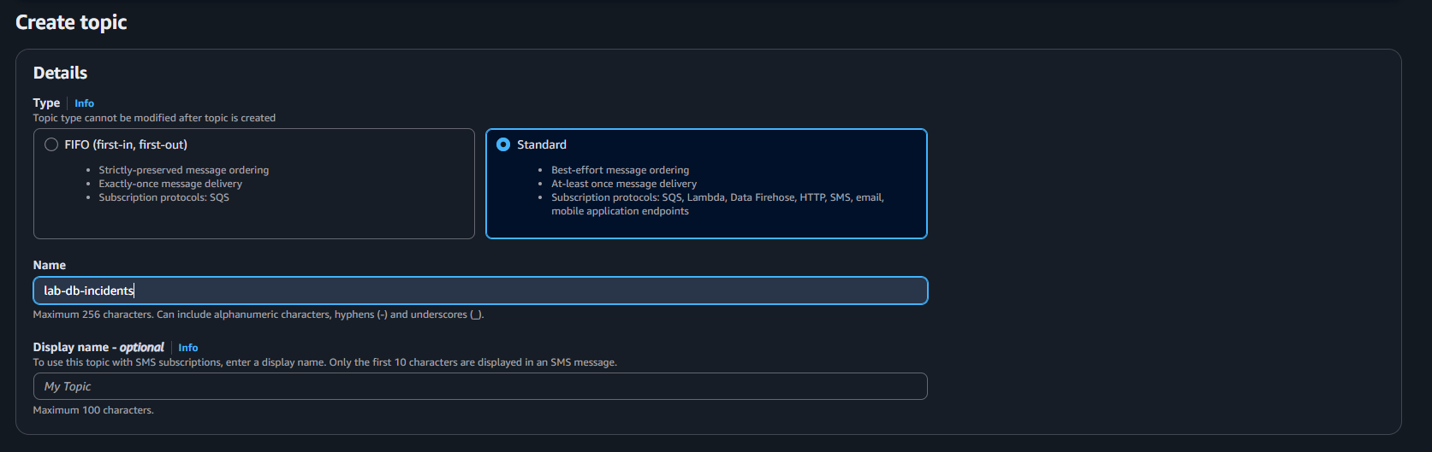
Subscription Create subscription
Details
Topic ARN: choose topic arn that you just created
Protocol: Email
Click Create subscription
